**WEEK 4**

**SPRING REST USING SPRING BOOT 3**

**1.Create a Spring Web Project using Maven**   
**CODE:**

**//SpringLearnApplication.java**

package com.cognizant.spring_learn;

import org.slf4j.Logger;

import org.slf4j.LoggerFactory;

import org.springframework.boot.SpringApplication;

import org.springframework.boot.autoconfigure.SpringBootApplication;

@SpringBootApplication

public class SpringLearnApplication {

private static final Logger LOGGER = LoggerFactory.getLogger(SpringLearnApplication.class);

public static void main(String[] args) {

LOGGER.info("START");

SpringApplication.run(SpringLearnApplication.class, args);

LOGGER.info("END");

}

}

**OUTPUT**

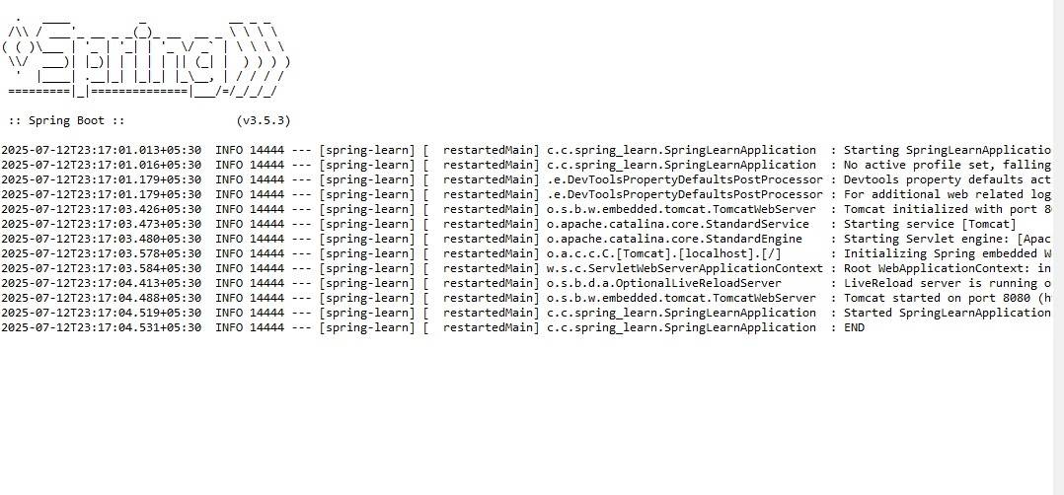

**2.Spring Core – Load Country from Spring Configuration XML**   
  
**Code:**

**//SpringLearnApplication.java**

package com.cognizant.spring_learn;

import org.slf4j.Logger;

import org.slf4j.LoggerFactory;

import org.springframework.context.ApplicationContext;

import org.springframework.context.support.ClassPathXmlApplicationContext;

public class SpringLearnApplication {

private static final Logger *LOGGER* = LoggerFactory.*getLogger*(SpringLearnApplication.class);

public static void main(String[] args) {

*LOGGER*.info("Inside main()");

*displayCountry*();

}

public static void displayCountry() {

System.*out*.println("Inside displayCountry()");

ApplicationContext context = new ClassPathXmlApplicationContext("country.xml");

Country country = (Country) context.getBean("country", Country.class);

*LOGGER*.info("Country : {}", country.toString());

//System.out.println("Bean Loaded: " + country);

}

}

**//Application.properties:**

spring.application.name=spring-learn

server.port=8081

logging.level.com.cognizant=DEBUG

logging.level.root=DEBUG

**//SpringLearn/pom.xml**

<?xml version="1.0" encoding="UTF-8"?>

<project xmlns="http://maven.apache.org/POM/4.0.0" xmlns:xsi="http://www.w3.org/2001/XMLSchema-instance"

xsi:schemaLocation="http://maven.apache.org/POM/4.0.0 https://maven.apache.org/xsd/maven-4.0.0.xsd">

<modelVersion>4.0.0</modelVersion>

<parent>

<groupId>org.springframework.boot</groupId>

<artifactId>spring-boot-starter-parent</artifactId>

<version>3.5.3</version>

<relativePath/> <!-- lookup parent from repository -->

</parent>

<groupId>com.cognizant</groupId>

<artifactId>spring-learn</artifactId>

<version>0.0.1-SNAPSHOT</version>

<name>spring-learn</name>

<description>Demo project for Spring Boot</description>

<url/>

<licenses>

<license/>

</licenses>

<developers>

<developer/>

</developers>

<scm>

<connection/>

<developerConnection/>

<tag/>

<url/>

</scm>

<properties>

<java.version>17</java.version>

</properties>

<dependencies>

<dependency>

<groupId>org.springframework.boot</groupId>

<artifactId>spring-boot-starter-web</artifactId>

</dependency>

<dependency>

<groupId>org.springframework.boot</groupId>

<artifactId>spring-boot-devtools</artifactId>

<scope>runtime</scope>

<optional>true</optional>

</dependency>

<dependency>

<groupId>org.springframework.boot</groupId>

<artifactId>spring-boot-starter-test</artifactId>

<scope>test</scope>

</dependency>

<dependency>

<groupId>org.springframework.boot</groupId>

<artifactId>spring-boot-starter-logging</artifactId>

</dependency>

</dependencies>

<build>

<plugins>

<plugin>

<groupId>org.springframework.boot</groupId>

<artifactId>spring-boot-maven-plugin</artifactId>

</plugin>

</plugins>

</build>

</project>

**//Country.java**

package com.cognizant.spring_learn;

import org.slf4j.Logger;

import org.slf4j.LoggerFactory;

public class Country {

private static final Logger *LOGGER* = LoggerFactory.*getLogger*(Country.class);

private String code;

private String name;

// Constructor

public Country() {

*LOGGER*.debug("Inside Country Constructor.");

}

// Getter and Setter for code

public String getCode() {

*LOGGER*.debug("Inside getCode()");

return code;

}

public void setCode(String code) {

*LOGGER*.debug("Inside setCode()");

this.code = code;

}

// Getter and Setter for name

public String getName() {

*LOGGER*.debug("Inside getName()");

return name;

}

public void setName(String name) {

*LOGGER*.debug("Inside setName()");

this.name = name;

}

// toString method

@Override

public String toString() {

return "Country [code=" + code + ", name=" + name + "]";

}

}

**//Country.xml:**

<?xml version="1.0" encoding="UTF-8"?>

<beans xmlns="http://www.springframework.org/schema/beans"

xmlns:xsi="http://www.w3.org/2001/XMLSchema-instance"

xsi:schemaLocation="http://www.springframework.org/schema/beans

http://www.springframework.org/schema/beans/spring-beans.xsd">

<bean id="country" class="com.cognizant.spring_learn.Country">

<property name="code" value="IN" />

<property name="name" value="India" />

</bean>

</beans>

**OUTPUT**

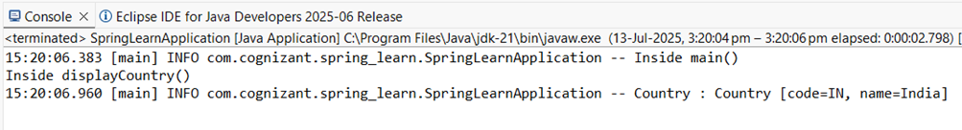

**3.Hello World RESTful Web Service**

**CODE:**

**//HelloController.java**

package com.cognizant.spring_learn;

import org.slf4j.Logger;

import org.slf4j.LoggerFactory;

import org.springframework.web.bind.annotation.GetMapping;

import org.springframework.web.bind.annotation.RestController;

@RestController

public class HelloController {

private static final Logger LOGGER = LoggerFactory.getLogger(HelloController.class);

@GetMapping("/hello")

public String sayHello() {

LOGGER.info("START sayHello()");

String message = "Hello World!!";

LOGGER.info("END sayHello()");

return message;

}

}

**//Application.properties**

spring.application.name=spring-learn

server.port=8083

**//SpringLearnApplication.java**

package com.cognizant.spring_learn;

import org.slf4j.Logger;

import org.slf4j.LoggerFactory;

import org.springframework.boot.SpringApplication;

import org.springframework.boot.autoconfigure.SpringBootApplication;

@SpringBootApplication

public class SpringLearnApplication {

private static final Logger LOGGER = LoggerFactory.getLogger(SpringLearnApplication.class);

public static void main(String[] args) {

LOGGER.info("START");

SpringApplication.run(SpringLearnApplication.class, args);

LOGGER.info("END"); }

}

**OUTPUT**

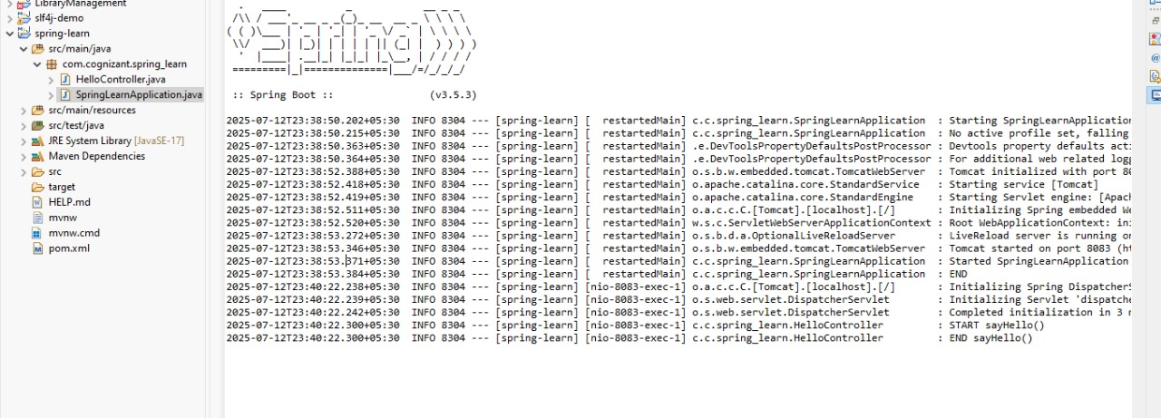

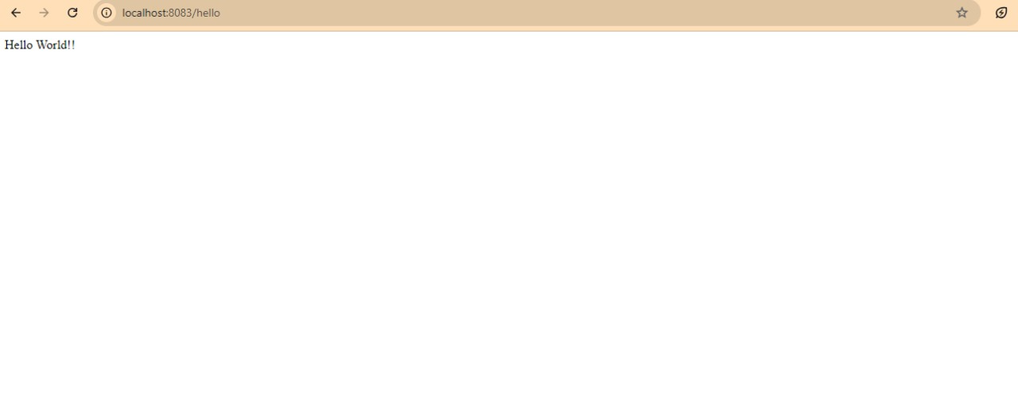

**4.REST country web service**

**CODE:**

**//CountryController.java**

package com.cognizant.spring_learn.controller;

import com.cognizant.spring_learn.Country;

import org.slf4j.Logger;

import org.slf4j.LoggerFactory;

import org.springframework.context.ApplicationContext;

import org.springframework.context.support.ClassPathXmlApplicationContext;

import org.springframework.web.bind.annotation.RequestMapping;

import org.springframework.web.bind.annotation.RestController;

@RestController

public class CountryController {

private static final Logger *LOGGER* = LoggerFactory.*getLogger*(CountryController.class);

@RequestMapping("/country")

public Country getCountryIndia() {

*LOGGER*.info("START - getCountryIndia()");

ApplicationContext context = new ClassPathXmlApplicationContext("country.xml");

Country country = context.getBean("country", Country.class);

*LOGGER*.info("END - getCountryIndia()");

return country;

}

}

**//Country.xml**

<?xml version="1.0" encoding="UTF-8"?>

<beans xmlns="http://www.springframework.org/schema/beans"

xmlns:xsi="http://www.w3.org/2001/XMLSchema-instance"

xsi:schemaLocation="

http://www.springframework.org/schema/beans

http://www.springframework.org/schema/beans/spring-beans.xsd">

<bean id="country" class="com.cognizant.spring_learn.Country">

<property name="code" value="IN"/>

<property name="name" value="India"/>

</bean>

</beans>

**//Country.java**

package com.cognizant.spring_learn;

import org.slf4j.Logger;

import org.slf4j.LoggerFactory;

public class Country {

private static final Logger *LOGGER* = LoggerFactory.*getLogger*(Country.class);

private String code;

private String name;

// Constructor

public Country() {

*LOGGER*.debug("Inside Country Constructor.");

}

// Getter and Setter for code

public String getCode() {

*LOGGER*.debug("Inside getCode()");

return code;

}

public void setCode(String code) {

*LOGGER*.debug("Inside setCode()");

this.code = code;

}

// Getter and Setter for name

public String getName() {

*LOGGER*.debug("Inside getName()");

return name;

}

public void setName(String name) {

*LOGGER*.debug("Inside setName()");

this.name = name;

}

// toString method

@Override

public String toString() {

return "Country [code=" + code + ", name=" + name + "]";

}

}

**//Application.properties**

spring.application.name=spring-learn

server.port=8084

logging.level.com.cognizant=DEBUG

logging.level.root=DEBUG

**//SpringLearnApplication.java**

package com.cognizant.spring_learn;

import org.springframework.boot.SpringApplication;

import org.springframework.boot.autoconfigure.SpringBootApplication;

@SpringBootApplication

public class SpringLearnApplication {

public static void main(String[] args) {

SpringApplication.*run*(SpringLearnApplication.class, args);

}

}

**

**5.REST – Country based on country code**

**CODE:**

**//CountryService.java**

package com.cognizant.spring_learn.service;

import com.cognizant.spring_learn.Country;

import org.springframework.context.ApplicationContext;

import org.springframework.context.support.ClassPathXmlApplicationContext;

import org.springframework.stereotype.Service;

import java.util.List;

@Service

public class CountryService {

public Country getCountry(String code) {

ApplicationContext context = new ClassPathXmlApplicationContext("country.xml");

List<Country> countries = (List<Country>) context.getBean("countryList");

return countries.stream()

.filter(country -> country.getCode().equalsIgnoreCase(code))

.findFirst()

.orElse(null);

}

}

**//Country.xml**

<beans xmlns="http://www.springframework.org/schema/beans"

xmlns:xsi="http://www.w3.org/2001/XMLSchema-instance"

xsi:schemaLocation="

http://www.springframework.org/schema/beans

http://www.springframework.org/schema/beans/spring-beans.xsd">

<!-- Single country bean -->

<bean id="country" class="com.cognizant.spring_learn.Country">

<property name="code" value="IN"/>

<property name="name" value="India"/>

</bean>

<!-- List of countries -->

<bean id="countryList" class="java.util.ArrayList">

<constructor-arg>

<list>

<bean class="com.cognizant.spring_learn.Country">

<property name="code" value="IN"/>

<property name="name" value="India"/>

</bean>

<bean class="com.cognizant.spring_learn.Country">

<property name="code" value="US"/>

<property name="name" value="United States"/>

</bean>

<bean class="com.cognizant.spring_learn.Country">

<property name="code" value="JP"/>

<property name="name" value="Japan"/>

</bean>

<bean class="com.cognizant.spring_learn.Country">

<property name="code" value="DE"/>

<property name="name" value="Germany"/>

</bean>

</list>

</constructor-arg>

</bean>

</beans>

**//CountryController.java**

package com.cognizant.spring_learn.controller;

import com.cognizant.spring_learn.Country;

import com.cognizant.spring_learn.service.CountryService;

import org.springframework.beans.factory.annotation.Autowired;

import org.springframework.web.bind.annotation.*;

@RestController

public class CountryController {

@Autowired

private CountryService countryService;

@GetMapping("/countries/{code}")

public Country getCountry(@PathVariable String code) {

return countryService.getCountry(code);

}

}

**//Application.properties**

spring.application.name=spring-learn

server.port=8084

logging.level.com.cognizant=DEBUG

logging.level.root=DEBUG

**//SpringLearnApplication.java**

package com.cognizant.spring_learn;

import org.springframework.boot.SpringApplication;

import org.springframework.boot.autoconfigure.SpringBootApplication;

@SpringBootApplication

public class SpringLearnApplication {

public static void main(String[] args) {

SpringApplication.*run*(SpringLearnApplication.class, args);

}

}

**OUTPUT**

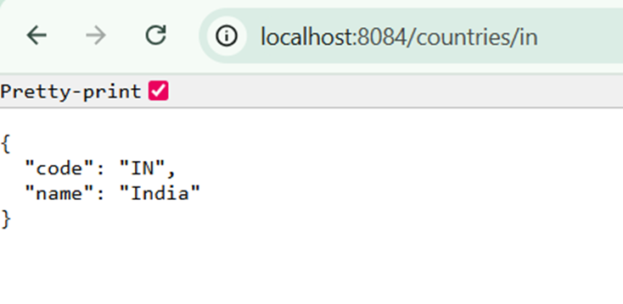

**6.Create authentication service that returns JWT**

**CODE;**

**//AuthenticationController.java**

package com.cognizant.spring_learn.controller;

import org.springframework.http.HttpHeaders;

import org.springframework.http.HttpStatus;

import org.springframework.http.ResponseEntity;

import org.springframework.web.bind.annotation.*;

import java.util.Base64;

import jakarta.servlet.http.HttpServletRequest;

@RestController

public class AuthenticationController {

@GetMapping("/authenticate")

public ResponseEntity<?> authenticate(HttpServletRequest request) {

String authHeader = request.getHeader(HttpHeaders.*AUTHORIZATION*);

if (authHeader == null || !authHeader.startsWith("Basic ")) {

return ResponseEntity.*status*(HttpStatus.*UNAUTHORIZED*).body("Unauthorized");

}

// Decode credentials

String base64Credentials = authHeader.substring("Basic ".length());

byte[] decodedBytes = Base64.*getDecoder*().decode(base64Credentials);

String credentials = new String(decodedBytes);

String[] values = credentials.split(":", 2);

String username = values[0];

String password = values[1];

if ("user".equals(username) && "pwd".equals(password)) {

return ResponseEntity.*ok*().body("{\"token\":\"dummy-token-for-user\"}");

} else {

return ResponseEntity.*status*(HttpStatus.*UNAUTHORIZED*).body("Unauthorized");

}

}

}

**//SecurityConfig.java**

package com.cognizant.spring_learn.config;

import org.springframework.context.annotation.Bean;

import org.springframework.context.annotation.Configuration;

import org.springframework.security.config.annotation.web.configuration.EnableWebSecurity;

import org.springframework.security.web.SecurityFilterChain;

import org.springframework.security.config.annotation.web.builders.HttpSecurity;

@Configuration

@EnableWebSecurity

public class SecurityConfig {

@Bean

public SecurityFilterChain filterChain(HttpSecurity http) throws Exception {

http

.csrf(csrf -> csrf.disable()) // disable CSRF for simplicity

.authorizeHttpRequests(authz -> authz

.requestMatchers("/authenticate").permitAll() // allow /authenticate without auth

.anyRequest().authenticated()

)

.httpBasic(); // enable HTTP Basic auth

return http.build();

}

}

**//Application.properties**

spring.application.name=spring-learn

server.port=8090

logging.level.com.cognizant=DEBUG

logging.level.root=DEBUG

**//SpringLearnApplication.java**

package com.cognizant.spring_learn;

import org.springframework.boot.SpringApplication;

import org.springframework.boot.autoconfigure.SpringBootApplication;

@SpringBootApplication

public class SpringLearnApplication {

public static void main(String[] args) {

SpringApplication.*run*(SpringLearnApplication.class, args);

}

}

**OUTPUT:**

{"token":"dummy-token-for-user"}